**Starbucks success: the secrets behind it**

As a business owner, it's important to stay ahead of the competition and find ways to differentiate your company from others in your industry. One way to achieve this is to take inspiration from successful companies like Starbucks and implement similar tactics in your own business. By adopting a multi-functional customer loyalty program, Starbucks has been able to differentiate itself in the competitive coffee industry.

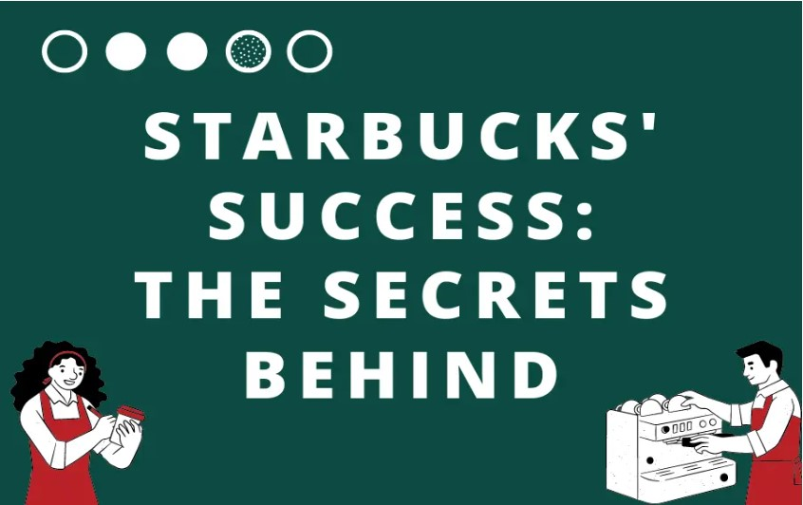

**Starbucks** owes much of its success to its distinctive business strategies. By incorporating similar tactics into your business, you can set yourself up for success in your industry and achieve greater customer **loyalty** and profitability. Don't be afraid to inspire the best and get involved to create a winning formula for your business.

Step into any city and chances are you'll spot a Starbucks - a testament to its unparalleled influence and success in the coffee industry. Starbucks, as the world's largest coffee company , surpassed its identity as an ordinary coffee chain, evolved into a cultural sensation that revolutionized our consumption and appreciation of coffee. With its innovative and diverse menu, it launched a crazy range of drinks, attracting and satisfying customers around the world. How did one Seattle coffee shop grow into a global empire, and what are the secrets behind its continued dominance and popularity?

## **Outstanding performance by Starbucks**

The success of Starbucks can be primarily attributed to the leadership and vision of its CEO, who spearheaded the expansion of the company. From December 31, 2022, [Starbucks](https://www.macrotrends.net/stocks/charts/SBUX/starbucks/revenue) achieved a total revenue of 8.714 billion dollars, which shows an impressive growth of 8.24% compared to the previous year. Furthermore, annual revenue has been on an upward trajectory since 2021 and is expected to continue to grow in the coming years. Despite a significant drop in revenue in 2020 caused by the COVID-19 pandemic, Starbucks rebounded in 2023 with an impressive comparable-store sales increase of 10% in the US and North America and 5% globally.

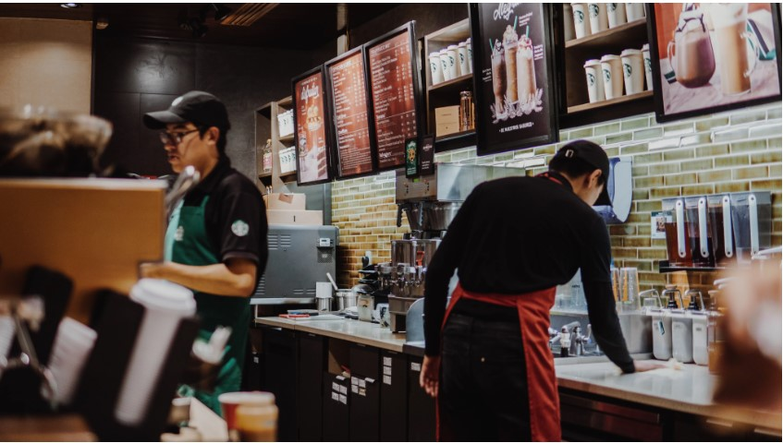

But what exactly sets Starbucks apart from other coffee industries? While the high-quality coffee and cozy atmosphere contribute to its appeal, there are many factors that set Starbucks apart in the industry. Let's uncover the secrets behind Starbucks' success and explore how they can inspire your business.

## **Innovative menu creation and promotion**

Despite coffee being the primary focus and strength of Starbucks, the company has diversified its offering to include a wide range of innovative food items while maintaining a high frequency of menu updates. Released in 2017, [the Starbucks Unicorn Frappuccino](https://www.businessinsider.com/starbucks-has-mastered-social-media-with-the-unicorn-frappuccino-2017-4) created buzz on social media with its eye-catching look and unique taste, where customers can stay up-to-date by viewing product photos and videos shared on **social media,** and businesses can form a strong relationship with customers accordingly. Starbucks increases **brand awareness** by maintaining an interactive presence on social networks and expands its potential audience through **influencer promotion** .

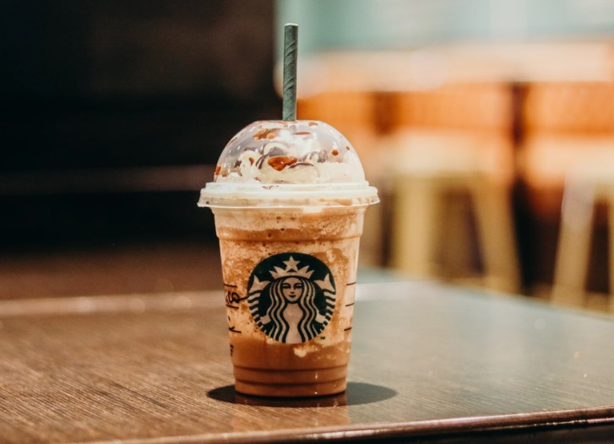

Another strategy to mention would be **limited time offers** . It creates **a sense of immediacy** that motivates customers to make an immediate purchase, while emphasizing the rarity of the product and inducing a sense of FOMO. This can be a powerful motivator for shoppers who don't want to miss out on a great deal or unique product. In addition, the implementation of buy - one-get - one-free , Happy Hours, free samples, and other promotional offers have also played a key role in Starbucks' growth.

## **Starbucks Rewards**

**Starbucks Rewards** is a loyalty program that rewards customers for their purchases. With purchases, customers can earn stars that can be redeemed for free food and drink, in-store refills, as well as other perks and benefits. This can increase **customer loyalty** and improve company profitability by expanding the customer base of loyal fans. Positive feelings about products and benefits can further strengthen customer retention rates and build a company's reputation.

**Mobile ordering** is an additional revenue stream for Starbucks. Customers can order and pay for their purchases in advance, eliminating the need to visit a location and physically wait in line. By integrating rewards earning with **mobile apps** , customers are motivated to try the mobile ordering feature, which can stimulate spending and increase sales. Another key benefit of a mobile ordering app is the shortcut **to data analysis** . By gathering information about customer orders and preferences, businesses can gain a comprehensive understanding of customer behavior, which can be used to develop marketing strategies that drive increased profitability.

Adopting a combination of environmental protection and rewards is a brilliant idea for promoting **the company's sustainability efforts** and establishing **a positive brand image** . Starbucks offers discounts and other incentives to customers who support the company's green initiatives, such as bringing their own reusable cups or using a mobile app to pay for purchases, which can encourage customers to adopt environmentally friendly behaviors.

Overall, the combination of Starbucks' unique brand image and multi-functional **customer loyalty program** has helped set the company apart and fueled its continued success in the highly competitive coffee industry. Companies that want to achieve similar success can get inspiration from Starbucks and create their own loyalty program at <https://toployalty.fun/bs-ba>.

Don't miss the opportunity to differentiate your business and increase customer loyalty - start building your program today.